Passive Ionization
the underappreciated mitigation technique
Steve Fowler sfowler@sfowler.com
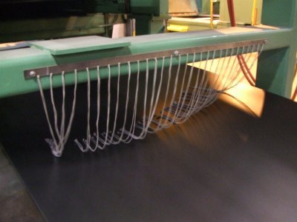
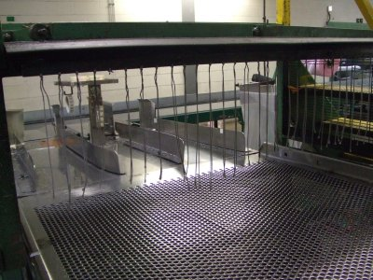

Abstract
Common electrostatic mitigation techniques involve grounding of conductors and neutralization of insulators. In industrial processes charged insulators are problematic. Hazards include personnel injury and discomfort, product quality and fires and explosions. Neutralization is typically performed by powered ionizing bars and blowers. Passive ionizers are also used but not to their maximum effectiveness.
Introduction
Passive ionizers are used in mostly industrial applications. Their inability to achieve very low potentials required in electronics makes them not useful in these applications. This article will demonstrate how the generous use of passive ionizers will effectively maintain a low electrostatic potential throughout a process. Active powered ionizers such as blowers and bars are very effective. However, the cost to place them at all needed locations can be restrictive.

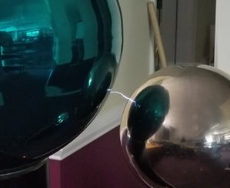
The breakdown of air is usually given as 3 million volts per meter or 30,000 volts per cm. However, this is for specific conditions such as electrode size, shape as well as speed of approach of the electrodes. In general, two conductive spheres raised slowly will breakdown at around 30,000 per cm. They provide a “capacitive discharge”. This discharge is rapid and energetic.

When the electrodes are pointed, the discharge becomes a corona discharge which is made up of ions flowing instead of an arc/spark. The ions allow the reduction or neutralization of potentials even on insulators by gently streaming ions. Below, a neon bulb with its sharp lead is pointed toward an operational Van de Graff generator. The neon bulb shows the sharp wire is streaming ions and lighting the bulb.
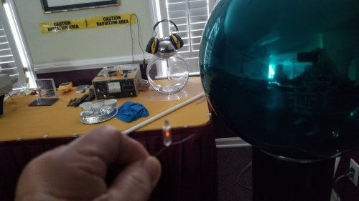

Powered ionizers use the same principle of the sharp points to create ions.
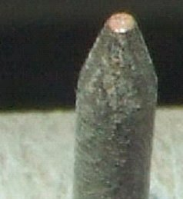
Several nail-like points are powered with a few thousand volts potential either as pulsed d.c or a.c. This causes positive and negative ions to flow between the ionizer and the charged object to neutralize the charges and reduce the potentials.

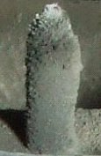

Since they are continuously powered, ions cause back streaming of contaminates which reduce the effectiveness of the points. Most ionizers have a method of cleaning the points with scheduled maintenance.

With passive ionizers, the charged object provides the potential to cause ions to flow. Powered ionizers may put out a maximum quantity of ions per second. Passive ionizers provide ions at whatever rate necessary due to the charged objects rate of charge and motion.
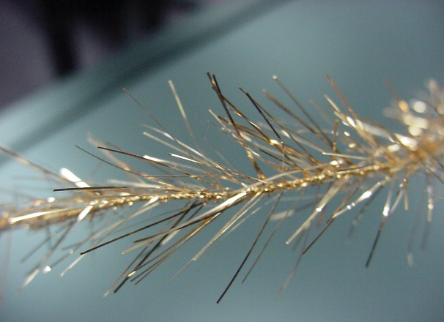
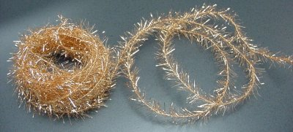
The most common passive ionizer is copper static tinsel. In the past Christmas tinsel made from aluminum was used as a very inexpensive passive ionizer. The old tinsel caused tree fires; present day Christmas tinsel is made from metallized polyester which does not work well.

The tinsel has many sharp points per inch making it an effective ionizer.
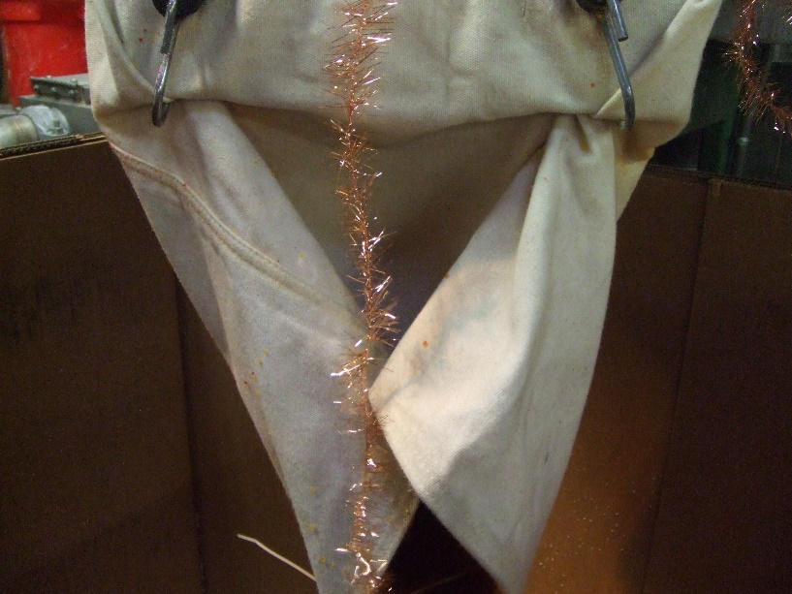

This shows one use of the tinsel in a polymer pelletizing operation. It makes the pellets low in potential giving the operator a more comfortable job.
Other passive ionizers include the following:
Threads of conductive fibers which may be incorporated into threads, cords and fabrics.

These threads are available in several constructions. Core conductive, surface conductive made with carbon, silver, copper and stainless steel. The chose of which fiber to be used depends on the application.
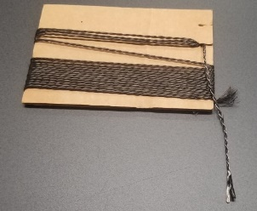
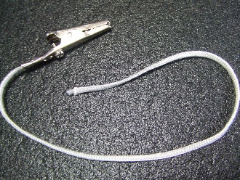
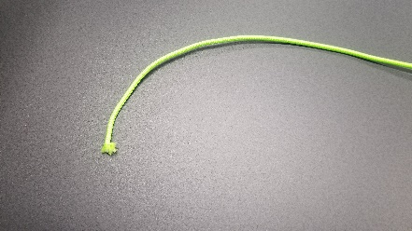

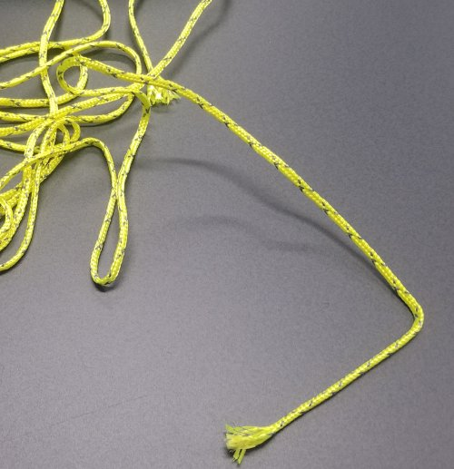

The following are prototypes ropes for discharging helicopters in dusty or rain environments

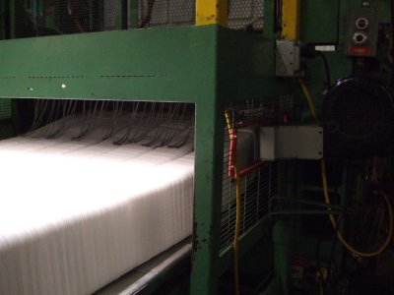
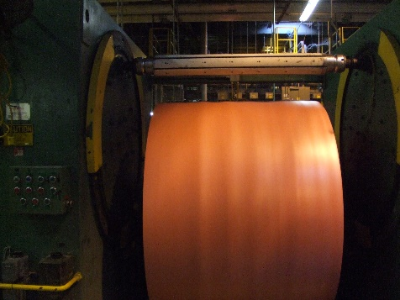
Small cords used in plastics manufacturing is a main application of passive ionizers

Any conductive materials with small profile and points may be used as a passive ionizer.
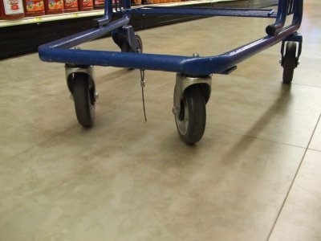

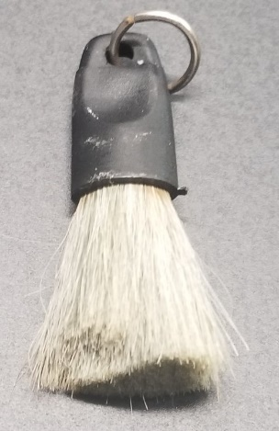
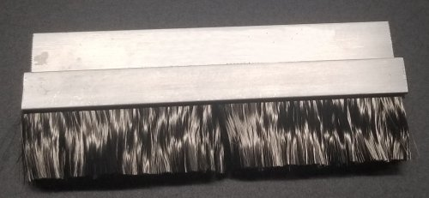
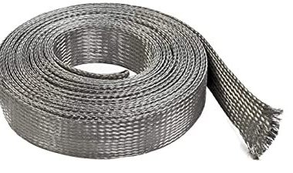
Safety cable in a scrap poly silo on a grocery cart

Braided flat cable Brushes

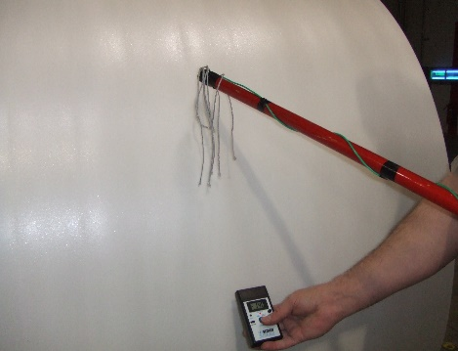
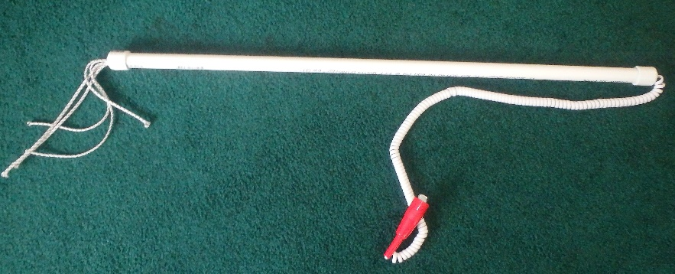

Passive ionization wands are used for areas where “in line” application is not possible such as large turret winders
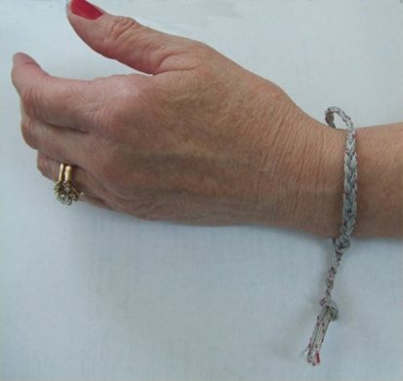
Interesting applications are for treadmills where the person receives shocks especially changing their phone music. Small cord passive ionizers made into a bracelet keeps the potentials comfortable.

Also, for shocks exiting vehicles and in grocery stores.

Passive Ionizer Protocols:
- Passive Ionizers should be used at each location where static is an issue. There cannot be too many passive ionizers from a static point of view. Passive ionizers should not be placed too close to active systems, as they will defeat the ability of the active system to put ions on the product.

Passive ionizers work best at very high potentials. They can only work effectively down to about 2 kV because the ability to maintain a corona discharge is lost at these levels. Usually, 2 kV is below the ignition point for most discharges from a practical standpoint and below any discomfort levels for personnel.

Passive Ionizer – Top and Bottom
Cross Position
Passive Ionizer – Top and Bottom
Linear Position
Passive Ionizer – Top Only
”Hippie Curtain” Draping Strings

- Passive Ionizer Placements: The above figure shows some of the best passive ionizer placements. The most efficient method is the linear position where a series of static tinsel strings are run in the machine direction both above and below the web. This allows more time in the neutralizing field to the tinsel.

- Passive Ionizers Principles: The placement of passive ionizers is important to their effectiveness. Some of the rules to follow are:

  - Use the most conductive materials possible for the passive ionizer.

  - Use the most “pointed” tinsel, string or brush possible.

  - Ground all passive ionizers.

  - Do not crowd the points of the passive ionizer. Points too close to each other form a plane not an ionizing point.

  - Place the passive ionizers just ahead of the area of concern for high charges and potentials. This may mean using many passive ionizers on a product line.

  - Place the ionizer at the maximum measured potential just ahead of the area of concern.

  - Place the passive ionizer as far away from metal machine parts and grounded objects as possible.

  - Place the passive ionizers on the side of the product of concern. This may mean both sides.

  - Place the passive ionizer with the maximum coverage of the product. Linear (machine direction) placements are best.

10. Place the passive ionizer tips as close as possible to the product without dragging on the product.

Conclusions
Where static potentials require reducing with minimum cost and in multiple locations, passive ionizers are the method to be used.

