Static Electricity Causes Fires!
It may be a one in a million chance but with 11 billion refuelings in the USA each year, this means that up to 1000 times per year in the United States static electricity may ignite the gasoline vapors during refueling.

People have been killed or severely hurt doing something as simple as refueling their vehicle or gas container by Static Electricity.

Static electricity is generated by the gasoline being pumped into a vehicle or container and by you when you get out of the car or remove an article of clothing. Static charges are dangerous.

If static charges are allowed to discharge in the vapor areas a fire can occur. The results are frightening and may be devastating.

Most vehicle static fires are caused by a person re-entering the vehicle during refueling to get warm or put up a credit card, etc. When they go back to the nozzle area they discharge their static at in the vapor rich space around the refueling port and BOOM!!

Sometimes the hose, nozzle or even the car can ignite the gasoline vapors from static discharges

Most gasoline container refueling fires due to static electricity are caused by the container not being filled on the ground but in the back of a truck, the trunk of a car or the step of a van, etc.

In addition to the other warnings at the gas pump such as

- No Smoking

Turn Off Vehicle

No Open Flames

No Unapproved Containers

No Cell Phone Use

We need to be aware of the serious dangers of static electricity.

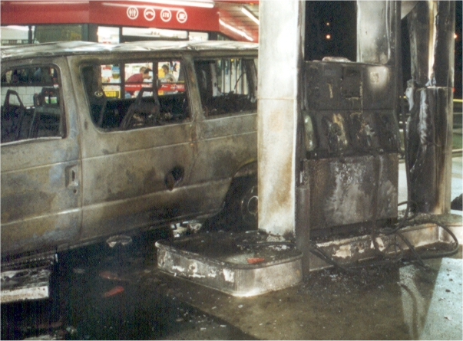

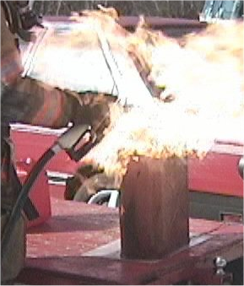
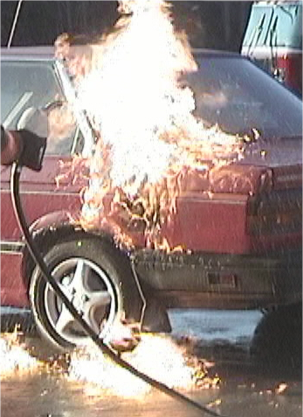

Be Aware at the Pump

Cell Phones: have never been shown to cause a static fire at the gas pumps. The main problem with cell phones is that they cause the person refueling their vehicle or container to be less attentive to their surroundings and their static charges. Do not use a cell phone at the pump.

Recreational Vehicles: RV’s and trailers may have lit pilot lights on them. Avoid them at the gasoline refueling stations.

Other People Refueling Their Vehicles or Containers: Be aware of the dangerous actions of other people at the refueling station. If you see someone smoking, refueling with the vehicle running or refueling containers not on the ground, etc., avoid them, tell the attendant, stop refueling and move to a safe distance.

New Static
Dissipative Signs

StaTouch Signs: Some gasoline distributors have put up warning signs to help the refueling public be aware of the dangers and the procedures to reduce static fires. StaTouch has taken the warning a step further. These signs provide a
safe place to gently
remove your static
each time you approach
the nozzle area.
SPINX Stations in
South Carolina were the
first to put the
StaTouch signs up.
http://www.statouch.com
800-258-5416

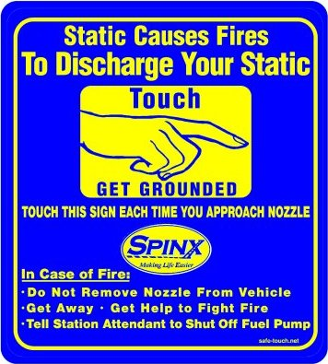

By
Fowler Associates

