RADIATION SAFETY OFFICER
CERTIFICATION COURSE

March 12 - 16, 2018



Fowler Asociates, Inc.
3551 Moore-Duncan Hwy. Moore, SC 29369 Tel: 864-574-6415 FAX: 864-576-4992
Email: sfowler@sfowler.com Web Site: www.sfowler.com

Fowler Associates
We are located in the “Upstate” of South Carolina off Interstate 85 between Greenville and Spartanburg. We are approximately 12 miles from the Greenville/Spartanburg airport (GSP). Our facilities on Highway 290 (exit #63 on I-85, Moore-Duncan Hwy.) just beyond the intersection of Highway 417. - 3rd building on the right.

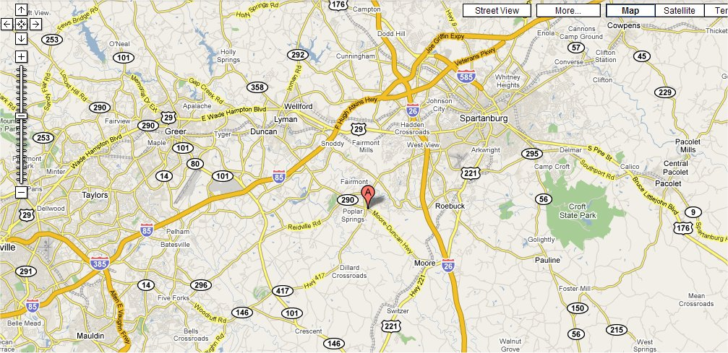
Greenville/Spartanburg Airport
Fowler Assoc

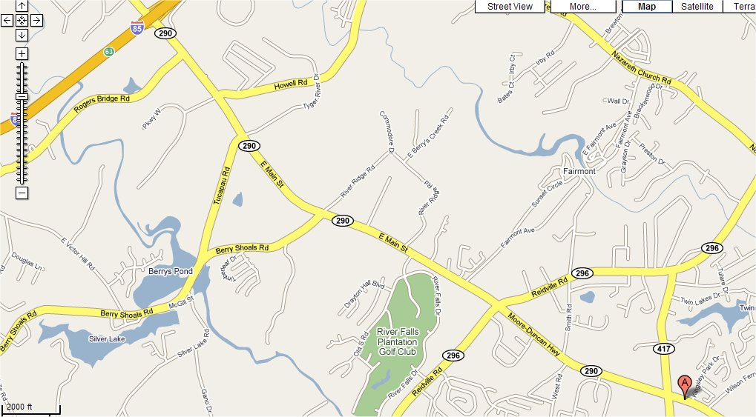
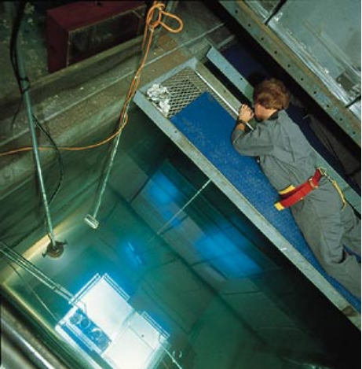
Fowler Assoc.
Cryovac Duncan

Monday, March 12th
Accelerated RSO Class – All week in one day

.. .9:00 ...........Radiation Safety Presentation
..9:00 - ..9:20 ...........S.I. Units..Dose
..9:20 - ..9:45 ...........Sources & Types of Radiation
..9:45 - 10:00............Radioactivity
10:00 - 10:30 ...........Interaction with Matter
10:30 - 10:45 ...........Coffee Break & Open Discussions
10:45 - 11:00 ...........Radiation Detection & Personnel Monitoring
11:00 - 11:40 .........."Radiation Protection Standards"
11:40 - 12:30 ...........Bological Effects of Radiation
12:30 - ..1:30 .......... Lunch “Medical Imaging – X-rays” - Movie
..1:30 -. .1:45 ...........Radiation Accidents
..1:45 -. .2:00 ...........Radon - in the Home and in the Workplace
..2:00 -. .2:30 ...........Handling of Radioactive Sources
..2:30 -. .2:45 ...........Coffee Break & Open Discussions
..2:45 -. .3:45 ...........Shielding & Surveys
..3:45 -. .4:00 ...........Personnel Issues & Radiation Safety Administration & Manual
..4:00 -. .4:30 ...........Transportation of Radioactive Materials
..4:30 -. .5:00 ........... Exam
5:00.......... Adjourn

Tuesday, March 13th

08:30 – 8:45 Math Review - Units of Dose

08:45– 10:00 Sources of Radiation and NORM

10:00 – 11:00 “Dirty Bombs” - Movie

11:00 – 11:20 Types of Radiation & Interaction with Matter

11:20 – 12:00 Radiation Protection Standards

12:00 – 1:00 Lunch - “Quarks to Atoms” - Movie

1:00 – 1:30 Radioactivity

1:30 – 2:30 Radiation Detection, Personnel Monitoring Systems

2:30 – 2:15 ”Labtoratory Techniques” - Radiation Safety Series

2:15 - 3:00 ”Emergency Procedures” - Radiation Safety Series

3:00 – 4:00 Determining Contamination and Counting Efficiencies

4:00 – 4:30 Radiation Safety Manual Discussions

4:30 Adjourn

Wednesday, March 14th

08:30 – 10:00 Surveys - Surveys Breakout Sessions – Find the Source

10:00 - 12:00 Biological Effects of Radiation

12:00 - 1:00 Lunch

1:00 – 3:00 Radiation Accidents

3:00 – 5:00 Shielding Concepts

5:00 Adjourn

Hors d'œuvres
Wine & Cheese
(and Single Malt Scotch too)
Wednesday May 14th 5:15 p.m.
on the patio at Fowler Associates
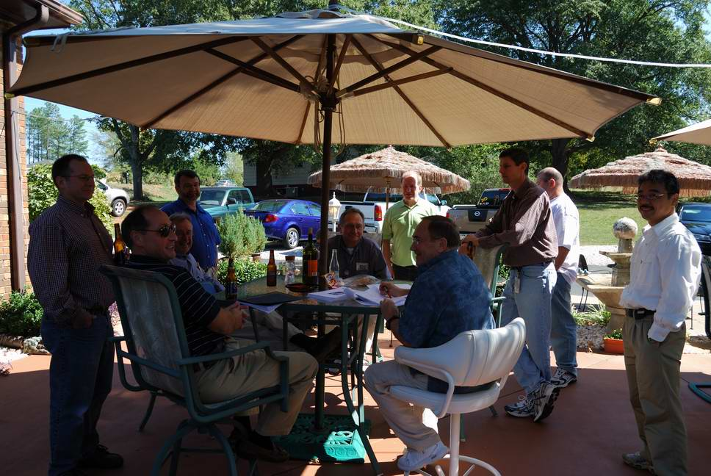

Thursday, March 15th

08:30 – 10:15 Shielding Review

10:15 – 12:00 Shielding Breakout Sessions – Determining HVL’s

12:00 - 1:00 Lunch

1:00 – 2:00 Questions & Answer Period

2:00– 3:00 Transportation – Radiation Tidbits/Miscellania

3:00– 3:30 Radon

3:30– 4:00 Radiation on the Internet and Research Materials

4:00 – 5:00 Radiation Safety Manual and Emergency Procedures Discussions

5:00 Adjourn

Friday, March 16th

08:30 – 10:00 Course Review

10:00 - 11:00 Questions-Answers-Group Discussions

11:00 - 03:00 Certification Exam

Since the Exam is open book, coffee breaks and lunch will be served during the exam period. All exams must be finished before 3:00 p.m

03:00 Adjourn

Note: Please, do not schedule to leave exam room prior to 3 p.m. for return transportation. We have had people finish in 20 minutes and as long as 6 hours.

THE EXAM

All Multiple Choice Questions

50 questions worth 2 points each = Total Points = 100 points
These questions will be either right or wrong - no partial credit given

Exam Grade System

Minimum Passing Score 70%

International Registry of Radiation Safety Officers
http://www.radjournal.com/irrso/irrsohomepage.htm



All RSO candidates who achieve at least an 80% score on the final exam may submit their resume' and application to the International Registry of Radiation Safety Officers. If minimum qualifications on experience and education are met the candidate will be listed for a period of four years in the registry and is entitled to use the SEAL and title: RSO.

Successful complettion of the exam also helps prepare the participant for the NRRPT exam and registration.



