Accelerated
RADIATION SAFETY OFFICER
Class



Fowler Associates, Inc.
3551 Moore-Duncan Hwy. Moore, SC 29369 Tel: 864-574-6415 FAX: 864-576-4992
Email: sfowler@sfowler.com Web Site: www.sfowler.com

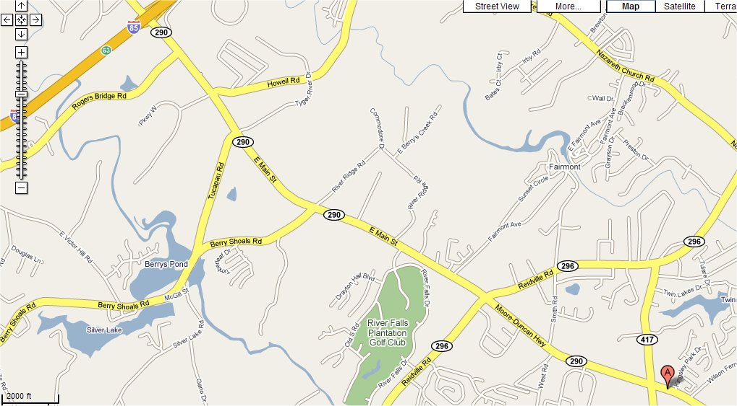
Fowler Assoc.
Cryovac Duncan

Accelerated RSO Class – All week in one day

.. .9:00 ...........Radiation Safety Presentation
..9:00 - ..9:20 ...........S.I. Units..Dose
..9:20 - ..9:45 ...........Sources & Types of Radiation
..9:45 - 10:00............Radioactivity
10:00 - 10:30 ...........Interaction with Matter
10:30 - 10:45 ...........Coffee Break & Open Discussions
10:45 - 11:00 ...........Radiation Detection & Personnel Monitoring
11:00 - 11:40 .........."Radiation Protection Standards"
11:40 - 12:30 ...........Bological Effects of Radiation
12:30 - ..1:30 .......... Lunch “Medical Imaging – X-rays” - Movie
..1:30 -. .1:45 ...........Radiation Accidents
..1:45 -. .2:00 ...........Radon - in the Home and in the Workplace
..2:00 -. .2:30 ...........Handling of Radioactive Sources
..2:30 -. .2:45 ...........Coffee Break & Open Discussions
..2:45 -. .3:45 ...........Shielding & Surveys
..3:45 -. .4:00 ...........Personnel Issues & Radiation Safety Administration & Manual
..4:00 -. .4:30 ...........Transportation of Radioactive Materials
..4:30 -. .5:00 ........... Exam
5:00.......... Adjourn

